Completing Your Annual COVERD Collaborative Partnership Agreement
- Log into your Neon account using this link:
- https://sweetcheeksdiaperbanks.z2systems.com/np/clients/sweetcheeksdiaperbanks/login.jsp
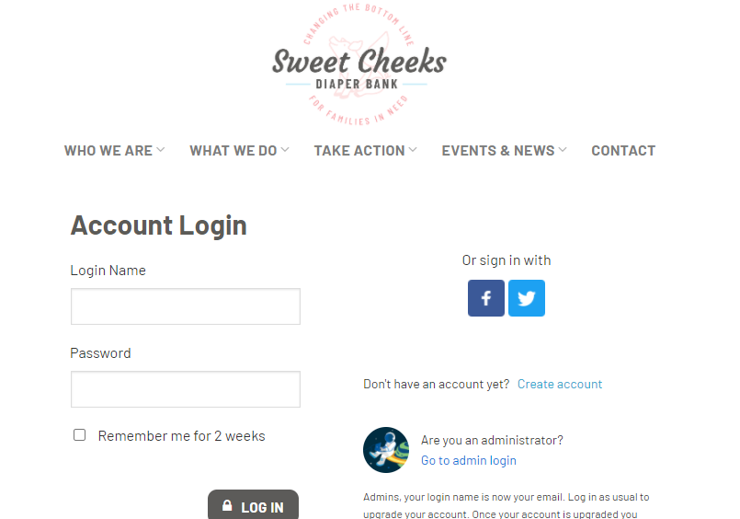

- Once you are logged in, click the following link: https://sweetcheeksdiaperbanks.z2systems.com/survey.jsp?surveyId=9&
NOTE: ONLY ONE PERSON PER ORGANIZATION SHOULD COMPLETE THIS FORM.

- Next, you’re going to complete the form (see example screen shot below). You will enter your Agency Name, the year, and select which tier levels you wish to partner with us for Sweet Cheeks Diaper Bank and Tidal Babe. You will also check the commitments you’re making to COVERD before signing and submitting the form. We strongly recommend reading this thoroughly so you fully understand both our commitment to you, and your commitments to us.
