Setting Up Your Neon Account

- You will receive an email that looks something like the image below, titled “COVERD Neon Account Registration.”
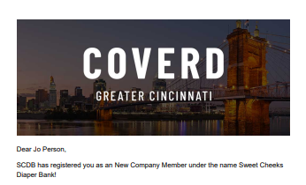
- In the email, you will find a link to create your account and password. Follow the link to the following screen, enter your email and click the “Send Recovery Email.”
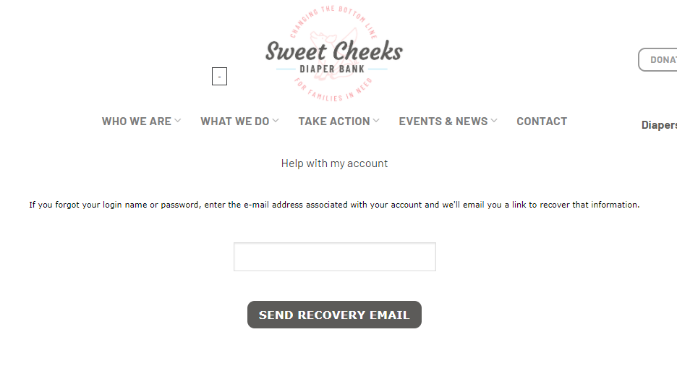
- Follow the link in the Recovery Email to the screen shown below in order to set up your User Name and Password, then click “Submit.”
