Completing Your SCDB Partner Agency Annual Report
- Log into your Neon account using this link:
- https://sweetcheeksdiaperbanks.z2systems.com/np/clients/sweetcheeksdiaperbanks/login.jsp
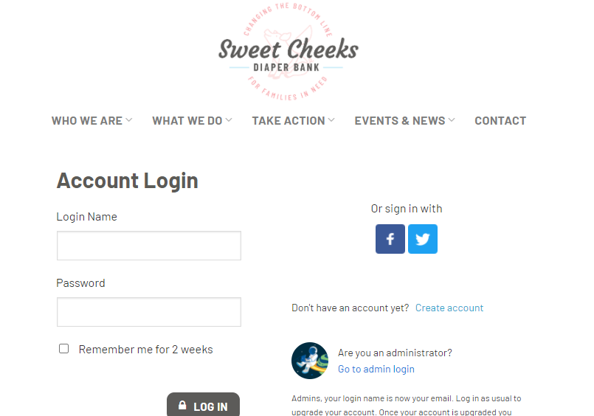

- Once you are logged in, click the following link: https://sweetcheeksdiaperbanks.z2systems.com/survey.jsp?surveyId=6&
NOTE: ONLY ONE PERSON PER ORGANIZATION SHOULD COMPLETE THIS FORM.

- Next, you’re going to complete the extensive form using the tracking sheet provided to you at the Annual Partner Agency Meeting in 2020. You cannot save progress, so make sure you have the information available to you and the time to completely fill in the document. Once the form is filled out in its entirety, click the “Submit” button.

