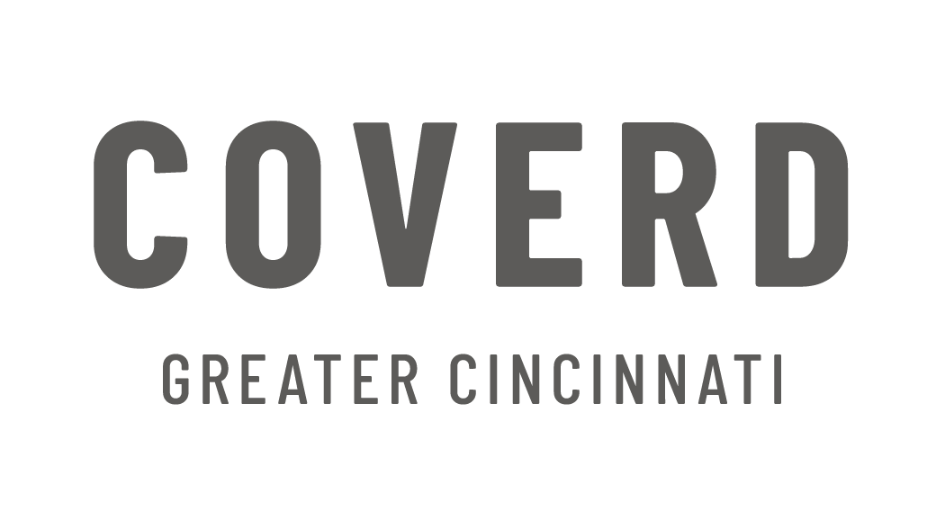
Dates/Deadlines (All Programs)
- All partners are responsible for checking the COVERD Bulletin Board on the 1st and 15th of each month
  - https://coverdgc.org/partner-agency-news-updates/
- Important Dates for Neon, Annual Agency Report, Partnership Renewal and Fees
  - Partner Organizations will receive their organization Neon account information by January 24th
  - Instructions for how to complete the Renewal Agreements and Agency Report will be posted on the Bulletin Board
  - Annual Partnership Renewal Agreements due January 31st, submitted in Neon
  - Annual Agency Report, completed in Neon, is due by February 21st and must be submitted before the organizations order will be accepted/processed
  - 2021 Agency Fees are due no later than May 31st
  - On June 1st, a 10% compounded fee will be applied to unpaid agency fees. An additional 10% compounded fee will be added on the 1st of each month until payment is received.
  - All partners will re-certify in DiaperBase at a yet to be determined date in 2021
- Miscellaneous Dates
  - Potty Training Kits will run out February 2021
  - We hope to have F&D live and funded for Meals on Wheels only in 2021
  - We hope to have F&D available to all partners in 2022
  - Potty Training Kits with Pull-Ups to relaunch under F&D
  - Partners will be notified when this is ready

